Path Planning Based on Indoor Positioning System for Mobile Robot
Luqman Hakim, Akhmad Hendriawan, Alrijadjis

Luqman Hakim
Electronics Engineering Studies Program D4
Eletronic Engineering Polytechnic Institute of Surabaya
Surabaya, Indonesia
luqman.hakim.eepis@gmail.com
Akhmad Hendriawan
Electronics Engineering Studies Program D4
Eletronic Engineering Polytechnic Institute of Surabaya
Surabaya, Indonesia
hendrieepis@gmail.com
Alrijadjis
Electronics Engineering Studies Program D4
Eletronic Engineering Polytechnic Institute of Surabaya
Surabaya, Indonesia
alrijadjis@pens.ac.id

Abstract— Navigation system and path planning are needed for robot to do maneuver in its environment. Some methods can be applied as the navigation system of the robot in indoor environment, one of the method is vision based location positioning that implement image database and location model, The image sequence is obtained by a wearable mobile PC with camera, then the obtained image is compared with the image database. The disadvantage of this method are the lighting condition around the environment that can make the visual recognition fails, and also the processing unit demands high power input, so this method is not efficient if applied to mobile robot that has very few functionality. The other method is odometry, a method to determine the relative position of the robot by calculating the wheel rotation. Of course this method will not work well in environment that has slippery ground making the rotary encoder sensor does miss reading. This research propose a new idea to improve the accuracy of navigation system of the mobile robot. This system uses wireless sensor network to do ranging measurement then do a calculation using trilateration method to determine the position of the mobile robot. Also magnetometer sensor used to determine the heading of the robot. From the examination we acquire that path planning using this indoor positioning system has average error of 4,34% when robot moves from initial position (0,0)m to target position (2,2)m and average error of 3,34 when robot moves from initial position (0,0)m to target position (4,4)m.

Keywords— mobile robot, path planning, indoor positioning system, navigation

Introduction
This research presents navigation system used by a mobile robot in indoor environment, the aim of the system is to determine the robot position in indoor place as well as the robot’s heading determination. The aim of the sensors system is to obtain the absolute position and orientation of the mobile robot that are immune to disturbance that affect the relative sensory like rotary encoder that coupled to the robot’s wheels. The position and the orientation of the robot will be used to navigate around the environment.[1] Mobile robot uses path planning to achieve best possible path to move from one position to another position.[2]
One of the method is vision based location positioning [3] that implement image database and location model that is less efficient if used for mobile robot. Odometry is another method that can be used to determine the position of the mobile robot using relative sensor by calculating the rotation of the robot’s wheels. There will be a problem if the wheels is slipping away making the odometry system fails to determine the exact position and orientation of the robot. As stated by Bayu Sandi Marta in his research, he draw a conclusion that, “Odometry has a limitation that will only work well if the environment is not slippery [4]”. Also stated by Jusuf Dwi Kariyanto that, “the performance of the odometry is affected by the slip of the wheels, the longer and windier the path, the greater the potential of wheel slipping away. [5]
This research presents a solution to make an absolute positioning and orientating for the mobile robot by using indoor positioning system to determine the position of the robot by using trilateration as well as heading of the robot by calculating the earth magnetic direction using magnetometer sensor. The indoor positioning system uses wireless sensor network, 3 sensor node act as anchor and 1 sensor node act as tag.

METHODS

Odometry
Odometry is a method to determine the position displacement time by time by using data acquired from actuator movement.[2] Odometry is used to determine position of the robot relative to initial position of the robot. The differential wheel system odometry shown in figure 1:
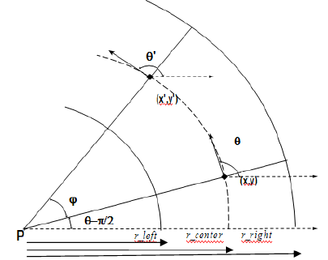
- A geometry of odometry.

Trilateration
Trilateration is a method to determine the position coordinate based on the distance of the determined point (tag) to the minimum of 3 known coordinate position (anchor).[6] To achieve the best result for determining the position, the placement of the anchor should shape triangle where the tag is in the middle of the anchors, as shown in figure 2.
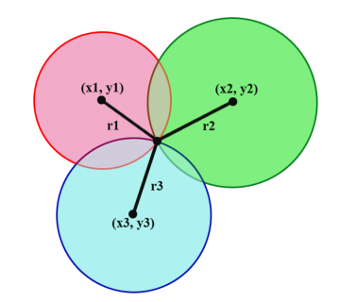
- Trilateration model.

System Block Diagram
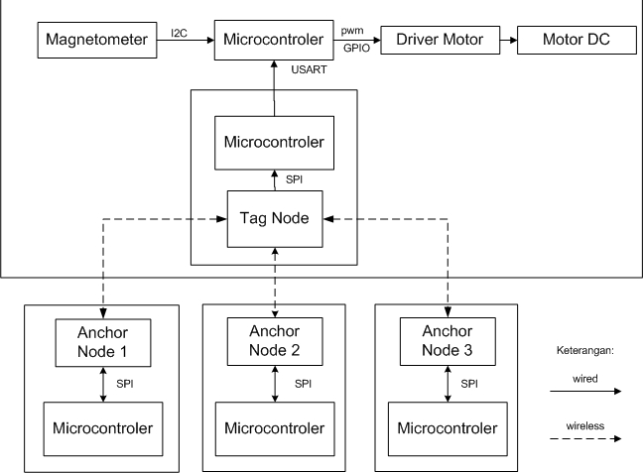
Robot
- Electronic system block diagram.
Figure 3 shows the system diagram consisted of a main controller unit and 4 auxiliary controller unit that handle the wireless sensor network that capable to do ranging measurement. The ranging data are the distance measurement between each anchor node to the tag node that sit on the mobile robot. The each node uses DWM1000 module that capable to do ranging controlled by Arduino Pro Mini, the ranging data then sent to the main controller via UART communication. The main controller of the robot is handled by STM32F407 ARM microcontroller. The main controller get ranging data from tag node and calculate the data to provide robot’s position using trilateration method. To determine robot’s heading, the main controller get data from magnetometer sensor via I2C then calculate the earth magnetic field to provide heading according to earth magnetic direction
.

Robot Design
The mechanic wheels of the robot use bidirectional omniwheel to ease the maneuver of the robot. By using this design the robot capable to move forward, backward, move aside, and rotating. The electronic boards sit on top of the robot mechanic base, there are 2 boards, the main control board and a board where the tag node sit. The power supply is provided by a 3-cell lithium polymer battery. The mechanic and hardware of the robot shown in figure 4.

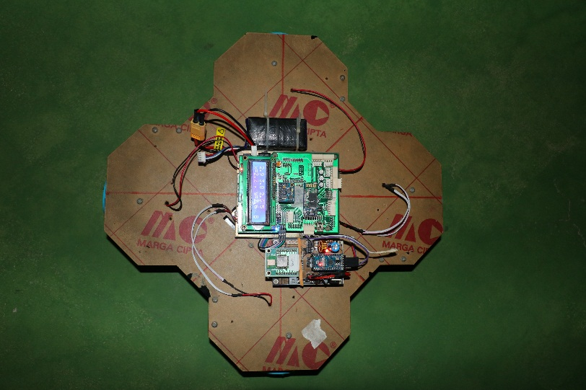
DWM1000
Board
main control system board
Power Supply (Battery)
- Hardware and mechanic of the robot.

Orientation and position determination
To determine heading direction, it need earth magnetic filed data that are read from magnetometer sensor. The magnetometer sensor reads earth magnetic field into two magnetic force direction and strength. The force divided into x direction and y direction. Them those two data are calculated and vectored to find the resultant direction. This resultant vector direction is used as the heading of the robot. Figure 5 shows the illustration of heading calculation. The equation to find the resultant vector direction is as follows:
………………………………(1)
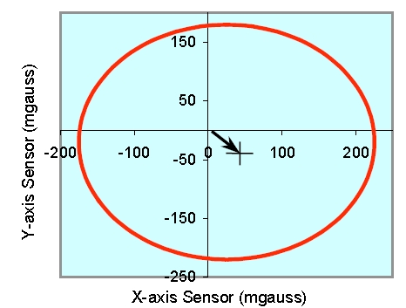
- Heading determination using magnetometer.
The calculation to determine the position in the field as x and y cordinate position is processed by the main controller by using trilateration method. To do trilateration calculation, it need the exact position of the anchors node on the field, there are anchor1(x1,y1), anchor2(x2,y2), and anchor3(x3,y3) in x and y coordinate, and the distance from tag node that sit on the robot to each anchor nodes that is r1, r2, and r. The trlateraton equaion [7] to determine the position of the robot uses these two equations, the equations is as follow:
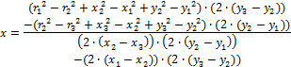
…………………………………………………….(2)

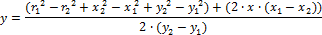
……………………………………………………(3)
In figure 6 shown the placement of the anchor nodes on the field with dimnesion of 5m x 5m.
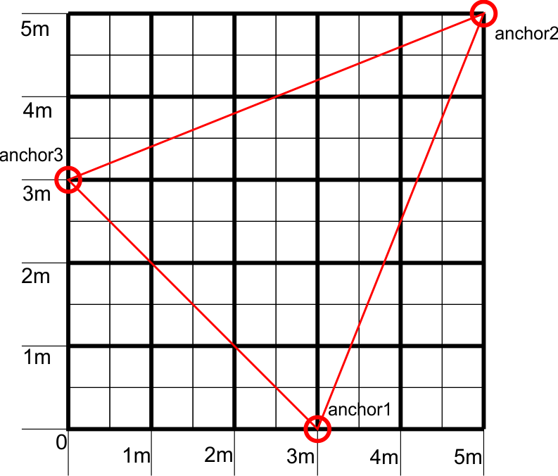
- Placement of anchor node.

Path planning and robot movement
The system design uses P(proportional) control to control the heading of the robot so the robot capable to maintain its heading toward the desired position. Path planning is made by determining the direction and distance from the initial position of the robot to the desired position in the field. The robot continuously determining the heading toward the desired position and the distance while the robot moving toward it. The robot will stop if it reach its desired position, the robot know when it reach the position by making calculation of the distance from where its position (by calculating trilateration) to the desired position. If the calculated distance is equal to zero, then the robot decide to stop.

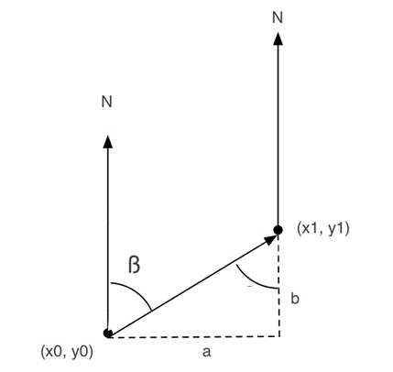
r
∆x
∆y
- Distance and bearing.
The figure 7 shows how to calculate the distance (r) from the robot’s position toward the desired position as well as the heading to the desired position known as bearing (β).
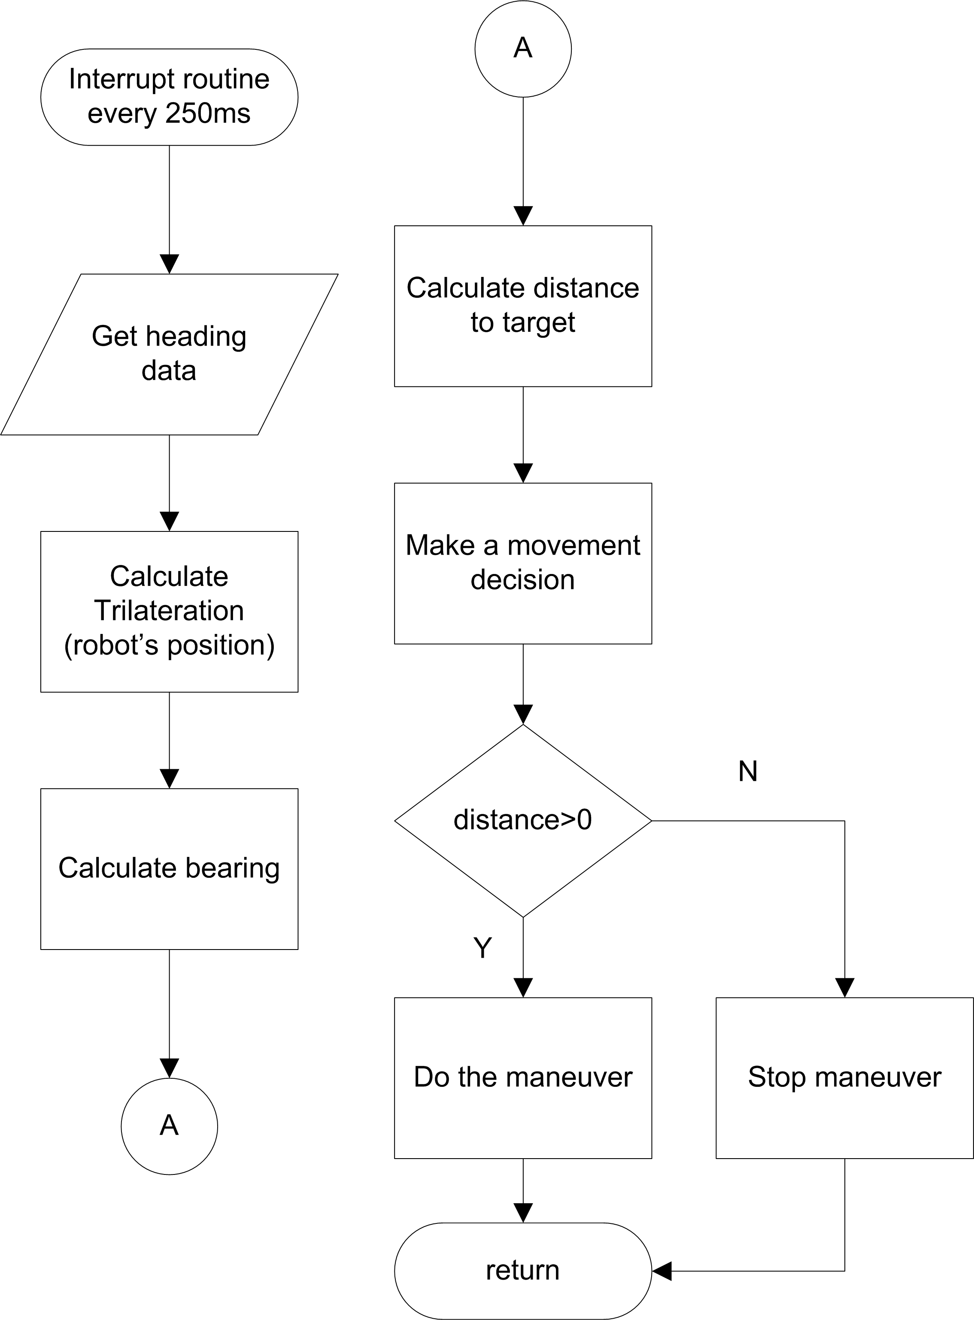
- Fowchart of path planning.
The figure 8 shows how the path planning system is made figured by a flowchart. The system use time scheduling so the path planning continously executed every 100ms according to the microcontroller timer.

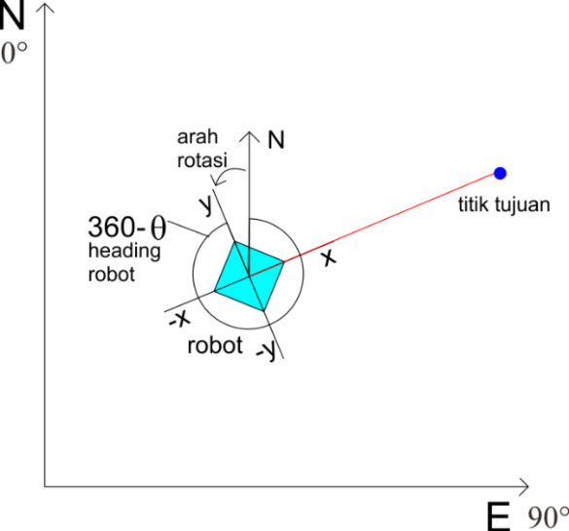
Direction of movement
- Ilustration of the robot movement.

The figure 9 shows the ilustration while the robot making a movement toward the desired position.
reference | raw x (mGauss) | raw y (mGauss) | Heading (degrees) | error heading (degrees)
0 | 456 | -18 | 0 | 0
40 | 356 | 262 | 38 | 2
90 | 15 | 416 | 91 | 1
120 | -209 | 364 | 122 | 2
180 | -456 | 14 | 180 | 0
240 | -244 | -354 | 238 | 2
270 | -11 | -413 | 270 | 0
320 | 337 | -282 | 322 | 2
360 | 456 | -18 | 0 | 0
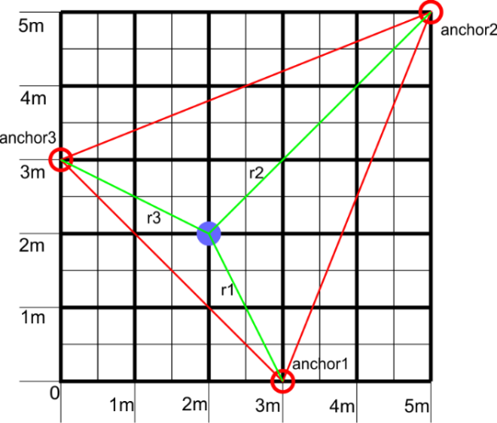
- Placement of anchor nodes and the robot on the field.

The figure 10 shows the placment of the anchor nodes as well as the robot in the field while the robot making a movement toward the desired position. The placement of the nodes has a shape of triangle in a rectangular field. The placement of the node are: anchor1on (3,0)m, anchor2 on (5,5)m, and anchor3 on (0,3)m. The field dimension is 5m x 5m.

Result

Magnetometer
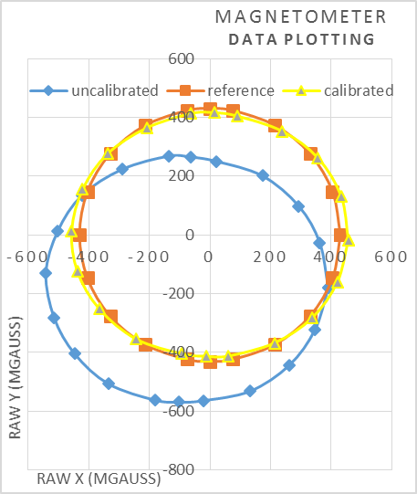

- Placement of anchor nodes and the robot on the field.
Table 1. heading result after calibration.

According to the uncalibareted raw data, shown in figure 11, it shows that it has an offset that make the value not in the center point, so the heading readout has a big error. To correct this the offset correction value has to be added. Here are the equation to correct the magnetometer offset value:
……………………………………….(4)
………………………………………..(5)
Where : = raw data in x axis
= calibrated data in x axis
= offset value for data in x axis
= raw data in y axis
= calibrated data in x axis
= offset value for data in x axis

In table 1 shown the calibrated data of mangetometer and calculated heading compared with actual earth magnetic heading shown by magnetic compass.

Ranging with DWM1000 module
In the table 2, shown the distance data acquired by ranging two DWM1000 module, and in figure 12 shown error value on each distance. The examination did by putting two DWM1000 module at certain distance and read the measurement of the distance provided by the DWM1000 module. According to the measurement by the DWM1000 module shown that the error of the distance measurement have bigger error when measuring a close distance between 1m to 6m, the errors are 5% up to 14%. And the errors are less than 3.3 % when measuring distance longer than 6m. See table 1.

Table 2. Ranging between two DWM1000 Module.
Reference distance (m) | Estimation (m) | Error(%)
1 | 1.14 | 14.00
2 | 2.21 | 10.50
3 | 3.26 | 8.67
4 | 4.42 | 10.50
5 | 5.25 | 5.00
6 | 6.32 | 5.33
7 | 7.23 | 3.29
8 | 8.27 | 3.37
9 | 9.32 | 3.56
10 | 10.35 | 3.50
Average error (%) |  | 5.02

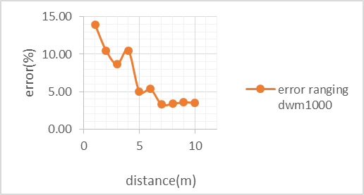
- Error of the ranging by DWM1000.

Trilateration
In table 3 shown the result of positioning using trilateration method, the examination take place in a plain field without obstacle. The tag node is put in the certain position on the field, then the node make a trilateration calculation to determine where its position. The position provided with the trilateration then compared to the real world measurement. The calculation of trilateration has bigger error when determining position coordinate of (1,1)m, resulting error with distance error 0.18m and (2,2)m resulting error with distance error 0.41m. To measure this distance error, simply by calculating the distance between the position shown by the tag node to the actual position by using Pythagoras equation. The calculation has average error is 5.05%.

…………………………………………………….(6)

Where : = distance error
= actual y axis measurement
= trilateration calculation in y axis
= actual x axis measurement
= trilateration calculation in x axis

Table 3 positioning using trilateration.
act_x (m) | act_y (m) | res_x (m) | res_y (m) | dis_error (m) | Error (%)
1 | 1 | 0.87 | 0.88 | 0.18 | 12.51
2 | 2 | 1.9 | 1.6 | 0.41 | 14.58
3 | 3 | 3.07 | 3.14 | 0.16 | 3.69
4 | 4 | 4.03 | 4.08 | 0.09 | 1.51
5 | 5 | 5.08 | 4.96 | 0.09 | 1.26
6 | 6 | 6.19 | 5.91 | 0.21 | 2.48
7 | 7 | 7.14 | 6.96 | 0.15 | 1.47
8 | 8 | 8.32 | 8.05 | 0.32 | 2.86
Average error (%) |  |  |  |  | 5.05

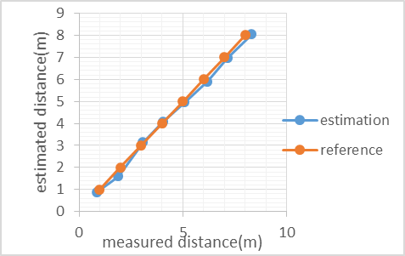
- Error of the ranging by DWM1000.

Path planning
This examination taken to test the performance of the path planning processed by the robot. The initial position of the robot is at (0,0)m, then the robot is given the position that the robot has to move there, the given position for the robot is at (4,4)m. The final position of the robot then compared to the exact position that the robot has to be there. The result of the accuracy of the robot making the maneuver to the desired position is presented in table 5. And the accuracy chart presented in figure 14.

Table 5. accuracy of the robot to reach desired position from (0,0)m to (4,4)m.
Examination number- | Robot’s final position in x axis (m) | Robot’s final position in y axis (m) | Distance to target (m) | Distance error (%)
1 | 3.97 | 4.12 | 0.12 | 2.19
2 | 4.19 | 3.91 | 0.21 | 3.71
3 | 3.93 | 4.17 | 0.18 | 3.25
4 | 4.19 | 3.91 | 0.21 | 3.71
5 | 3.99 | 3.7 | 0.30 | 5.30
6 | 3.95 | 4.14 | 0.15 | 2.63
7 | 4.14 | 3.89 | 0.18 | 3.15
8 | 3.95 | 4.11 | 0.12 | 2.13
9 | 4.14 | 3.87 | 0.19 | 3.38
10 | 4.12 | 3.94 | 0.13 | 2.37
average error (%) |  |  |  | 3.30

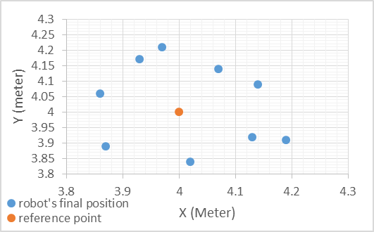
- Accuracy of the robot to reach desired position.

The result of the accuracy of the robot making the maneuver to the desired position from initial position (0,0)m to desired position (4,4)m is presented in table 6. And the accuracy chart presented in figure 15.
Table 6. accuracy of the robot to reach desired position from (0,0)m to (2,2)m.
Examination number- | Robot’s final position in x axis (m) | Robot’s final position in y axis (m) | Distance to target (m) | Distance error (%)
1 | 2.15 | 2.11 | 0.19 | 6.60
2 | 2.12 | 2.12 | 0.17 | 6.02
3 | 1.92 | 1.97 | 0.09 | 3.03
4 | 1.9 | 1.89 | 0.15 | 5.27
5 | 1.98 | 2.01 | 0.02 | 0.79
6 | 2.03 | 2.04 | 0.05 | 1.77
7 | 2.06 | 2.08 | 0.10 | 3.55
8 | 2.08 | 2.14 | 0.16 | 5.72
9 | 1.87 | 1.83 | 0.21 | 7.59
10 | 1.92 | 1.97 | 0.09 | 3.03
average error (%) |  |  |  | 4.34

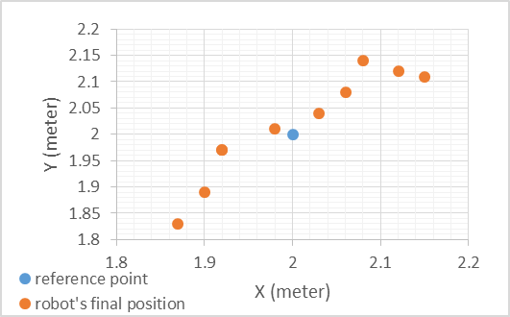
- Accuracy of the robot to reach desired position.

Path Tracking
In figure 16, presented the path tracking data while the robot making a maneuver from point to point. The figure shows that the robot is able to move according to the imaginary line made with the path planning, although there are some slight drift along the pathway. From the figure we can conclude that the robot is able to make the path planning and able to follow the path that is has made.

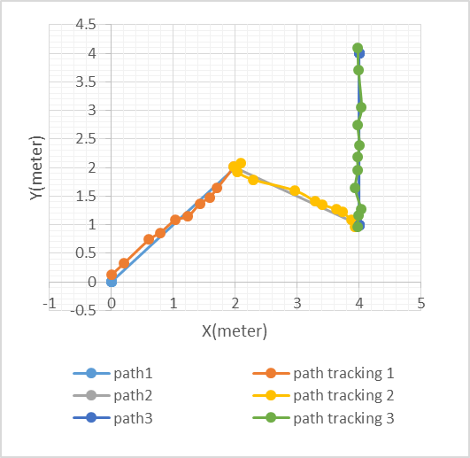
- Path tracking while the robot do a manuever.

Discussion
This research presents an alternative positioning method applied for mobile robot. The indoor positioning system using trilateration method that use wireless sensor network can provide an absolute positioning for the robot, whatever the disturbance applied to the robot, it won’t cause the miss reading to the position of the robot, thus this system has more robustness compared to the relative positioning like odometry that calculate the rotation of the robot’s wheels that tend to slip often when placed on the slippery surface, making the odometry system miss read the rotation of the wheel and miscalculate the position of the robot.
The indoor positioning system have better accuracy when equipped with the wireless sensor network that capable to do ranging in high precision level. The DWM1000 module can provide 10cm precision level in indoor place. This module uses UWB (Ultra Wide Band) technology which allows to do ranging with 10cm precision level.

Acknowledgment
Thanks to my family for the funding support to conduct this research, Mr. Akhmad Hendriawan for his guidance to finish my final project to build and design a path planning based on indoor positioning system for mobile robot.

Conclusion
- The determination accuracy of Position and orientation of the robot is very important to be used for determining the path planning.
- Wireless sensor network that capable to do distance measurement with high level precision can be used to apply indoor positioning system using trilateration method. Also the magnetometer sensor can be used to determine the orientation of the robot.
- By using indoor positioning system and earth magnetic direction for the robot, we are able to made absolute positioning for the robot.
- Indoor positioning system used as the absolute positioning for the robot has capability to avoid miscalculating when the robot start to slip away on slippery surface.
- By using DWM1000 module the determination of the tag position has average error of 5.05%.
- The magnetometer that is used to determine the orientation of the robot has average error of 3° compared to magnetic compass.
- According to the examination, it can be concluded that the application of indoor positioning system for path planning of mobile robot has accuracy with average error of 3.3 % where the robot move from initial position (0,0)m to desired position (4,4)m, and average error of 4.34 % where the robot move from initial position (0,0)m to desired position (2,2)m.

References

- Jonathan P. How, Brett Bethke, Adrian Frank, Daniel Dale, and John Vian, “Real-Time Indoor Autonomous Vehicle Test Environment”, IEEE CONTROL SYSTEMS MAGAZINE, APRIL 2008
- Torvald Ersson and Xiaoming Hu, “Path Planning and Navigation of Mobile Robots in Unknown Environments”, Optimization and Systems Theory / Centre for Autonomous Systems Royal Institute of Technology, SE 100 44 Stockholm Sweden
- JongBae Kim, HeeSung Jun, “Vision-Based Location Positioning using Augmented Reality for Indoor Navigation”, IEEE Transactions on Consumer Electronics, Vol. 54, No. 3, AUGUST 2008
- Bayu Sandi Marta, Fernando Ardilla, A.R. Anom Besari, “Path Tracking Pada Mobile Robot Dengan Umpan Balik Odometry”, Tugas akhir: Prodi Teknik Komputer, Politeknik Elektronika Negeri Surabaya Kampus PENS-ITS Sukolilo, Surabaya
- Jusuf Dwi Kariyanto, Ali Husein Alasiry, Fernando Ardila, Nofria Hanafi. “Navigasi Mobile Robot Berbasis Trajektori Dan Odometry Dengan Pemulihan Jalur Secara Otomatis”, Tugas akhir: Prodi Teknik Elektronika, Politeknik Elektronika Negeri Surabaya Kampus PENS-ITS Sukolilo, Surabaya
- O Anggarica Mudji Pratama, Taufiqurrahman, Prima Kristalina, “Real Time Visualization System untuk Monitoring Posisi Node pada Jaringan Sensor Nirkabel Berbasis Komunikasi Zigbee”, Prodi Teknik Telekomunikasi, Politeknik Elektronika Negeri Surabaya Kampus PENS-ITS Sukolilo, Surabaya.
- Lailul Rahmaniah, Yuliana Setiowati, Jauari Akhmad Nur Hasim, “Pemanfaatan Cubeacon Sebagai Media Geotagging Berbasis Android”, Prodi Teknik Informatika, Politeknik Elektronika Negeri Surabaya Kampus PENS-ITS Sukolilo, Surabaya.

